Simulation and synthesis report after synthesis

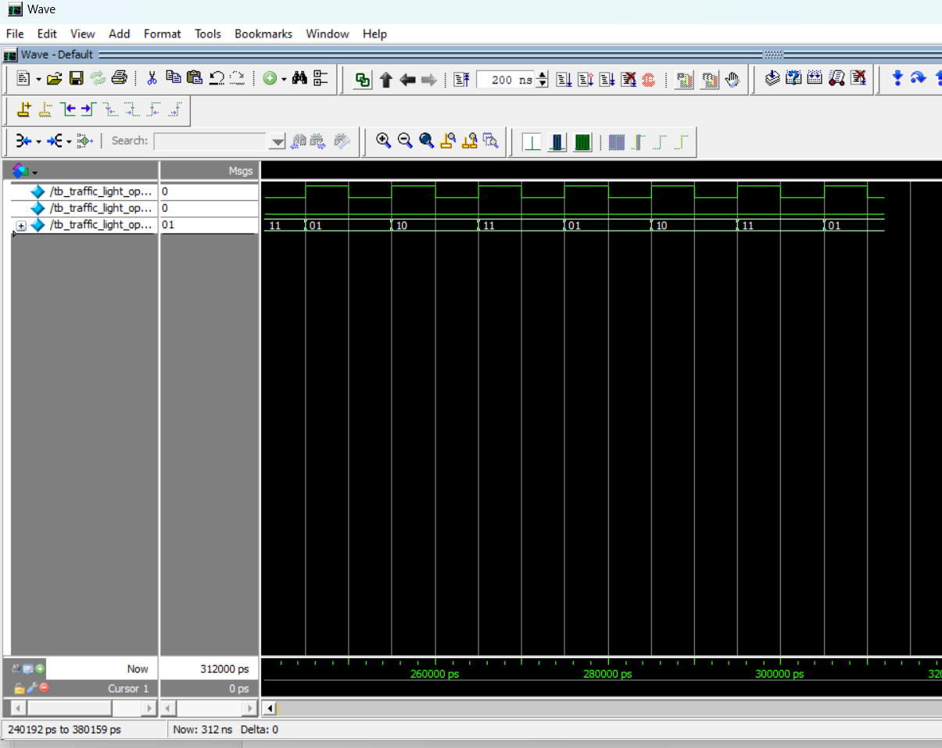

Modelsim report

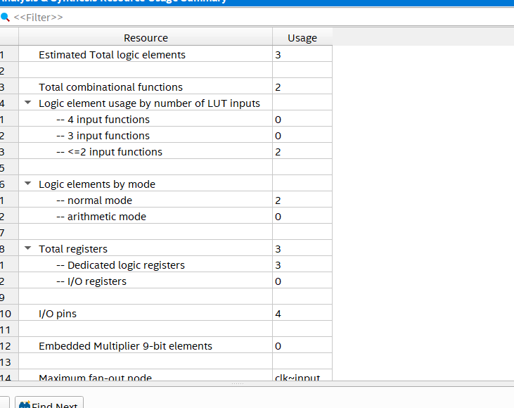

Quartus prime report